I have examined 2 websites for COVID-19 data. I initially wanted to extract COVID-19 data of my country, Bangladesh but I couldn't find any government website that shows the day to day numbers. They only provide the total number of patients, deceased, etc. So I gave up and started exploring the forum here and found "<https://www.covid19india.org/>" which contains a very well structured data set of COVID-19 in India and used their APIs to do some basic analysis of the data. Their JSON APIs are properly formatted so it was very easy but I wanted to do my own scraping. Then I found "<https://www.worldometers.info/coronavirus/>" which contains COVID-19 daily updated data from 15 February till now. The current pandemic piqued my personal interest in the data so I choose the above 2 websites. Unfortunately, I am not skilled in statistical analysis and mathematics so I just did very simple work.

1) The site "<https://www.covid19india.org/>" provides updated COVID-19 data and APIs that make data retrieving easier. Their APIs contain a lot of descriptive data like the daily cases and the gender, location, etc of the patients. But they do not have all the patients' data since they had to collect them personally (without the help of the Indian govt.). I used their APIs to find an approximate number of female and male patients from Jan 30 to May 15. The numbers here are lower than in reality.

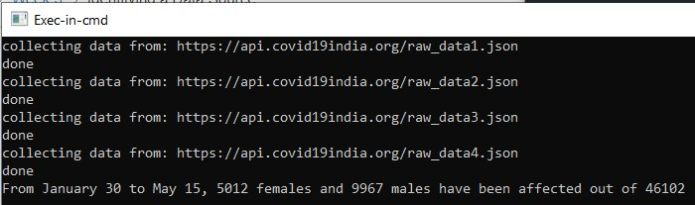

The screen snip below shows the accurate number of confirmed patients in India. The number of patients I've calculated from their APIs is lower.

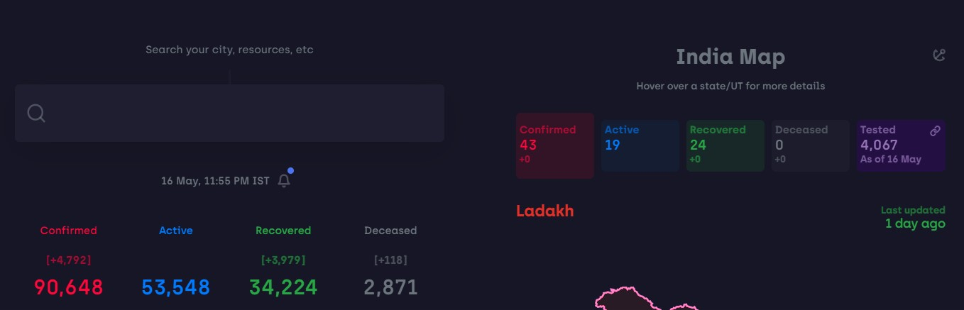

2) The site "<https://www.worldometers.info/coronavirus/country/bangladesh/>" contains the daily COVID-19 data but they do not provide any APIs. So I had to crawl my way to get the data. It was tough extracting data from an HTML containing nested javascript. I had to use BeautifulSoup to parse up to the javascript portion and then string manipulate my way to my desired data.

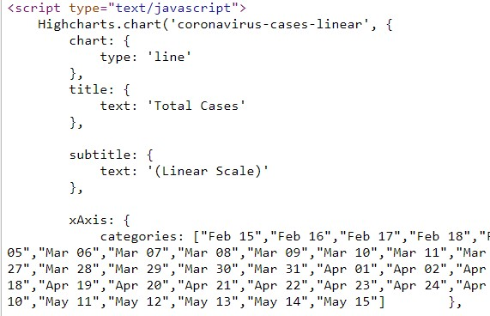

My program scraped the data and saved those in an excel. Then I made another simple program to dump the values from the excel. I will clean the data as there are some 'null' strings inside some cells (got the 'null' from the site's HTML).

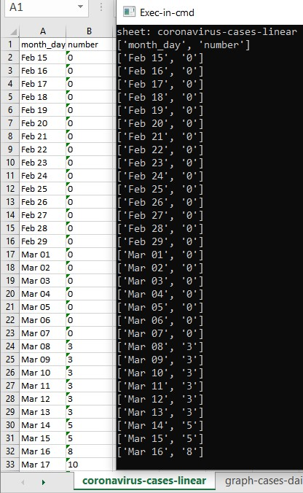

I haven't done any visualization yet. I plan to scrape data of all the countries on this website by spidering through the HTML (saw links of 215 countries) since this is the only website I found that contains daily figures.

That's all from me. Would love to have some suggestions on how to visualize the data.